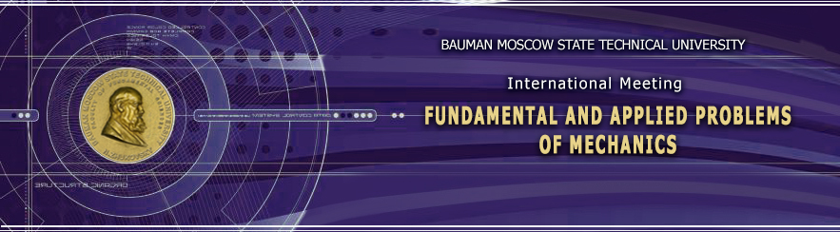
VIII International Scientific Conference
“Fundamental and applied problems of mechanics (FAPM-2022)”
December 6-9, 2022
Bauman Moscow State Technical University
Dear Colleague,
We invite you to participate in an international conference "Fundamental and Applied Problems of Mechanics (FAPM-2022)", which will be held from Thursday 6th December to Saturday 9th December 2022 at Bauman Moscow State Technical University.
Sessions will be held:
- in-person, in BMSTU rooms
- on-line, in Zoom
The scientific program includes reports on the following main areas:
- Mathematical modeling of mechanical systems, stability, oscillations, motion control
- Theoretical mechanics. Celestial mechanics
- Applied mechanics
- Aero- and hydromechanics
- Optimization and diagnostics of mechanical and hydromechanical systems
The "Scientific-methodical and historical questions of mechanics" panel involves members of the Presidium of the Scientific-Methodological Council on Theoretical Mechanics under the Ministry of Education and Science of the Russian Federation.
Conference site: http://fn.bmstu.ru/en/international-conference-fs-en/item/860-fundamental-and-applied-problems-of-mechanics-fs-en
E-mail: fapm@bmstu.ru / please, give your name and specify the type of material (application, abstract, theses, etc.) in the subject of the letter and attached files/
We invite you to take part in the conference!
As your abstracts will be included in the Conference Program, please, submit your applications and abstracts before November 11, 2022. Make sure that the files for submission are of A4 size and one page. The abstract submission rules are attached.
Extended abstracts can be of 3-5 pages, A4 size. Please, send them before December 1, 2022. If there are no extended abstracts, Conference Proceedings will include abstracts.
Conference Proceedings will have been released in the Scientific Conferences section of the electronic journal "Engineering Journal: Science and Innovations" by February 2023. Abstracts must comply with the journal requirements.
We are looking forward to your abstracts.
Conference Organizing Committee

